* Given the provided data, what are three conclusions that we can draw about crowdfunding campaigns?

Theater is the most widespread category with a peak in Kickstarters from May to July and fall in December.

We make an observation that Kickstarters in these recent years have more campaigns than earlier years do. Maybe because it was founded in 2009 and it’s basically a new company.

Music is the most successful parent category with lowest average funding goal.

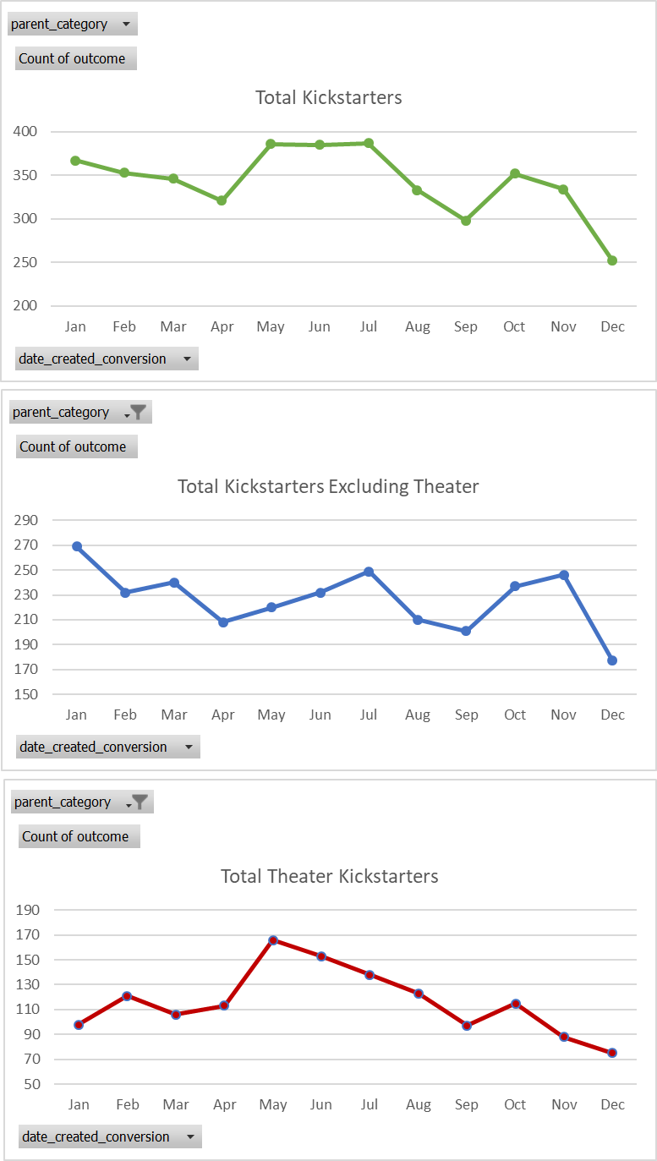of Kickstarters

|  |  |  |  |
| --- | --- | --- | --- |
| **Row Labels** | **Average of goal** | **Max of goal3** | **Min of goal2** |
| film & video | 49127.52809 | 197700 | 100 |
| food | 41767.3913 | 199000 | 100 |
| games | 59541.66667 | 197600 | 600 |
| journalism | 6425 | 9700 | 2400 |
| music | 40150.28571 | 198500 | 100 |
| photography | 32183.33333 | 191000 | 100 |
| publishing | 48359.70149 | 198600 | 100 |
| technology | 33097.91667 | 193400 | 100 |
| theater | 45459.01163 | 199200 | 100 |
| **Grand Total** | **43983.1** | **199200** | **100** |

* What are some limitations of this dataset?

Kickstarter was founded in 2009. So, it might be useful to have data on metrics for consumer preferences and trust in Kickstarter over time. Certain categories may be more successful during Kickstarter’s beginning while others are not due to lack of consumer trust.

The dataset provided insufficient information concerning what the donor will get in exchange of his/her donations. It could make a significant impact if the donor if aware of that.

* What are some other possible tables and/or graphs that we could create, and what additional value would they provide?

Possible tables and graphs we could create:

1. Tables showing:

The count of outcome for Parent category: canceled, failed, live, or successful. The count of outcome for Sub category: canceled, failed, live, or successful.

Parent category, Goal, and Sub category, median, max, and min.

Percent funded, and donation per category median, max, and min.

1. Graphs:

Graphs communicate information visually. They show patterns, help analysts identify correlations. Breaking up each category into subcategories would help us better understand the data.

Categories showcase different funding goals and average donations, and take place during years or seasons.